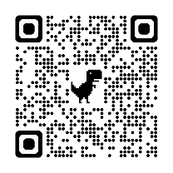
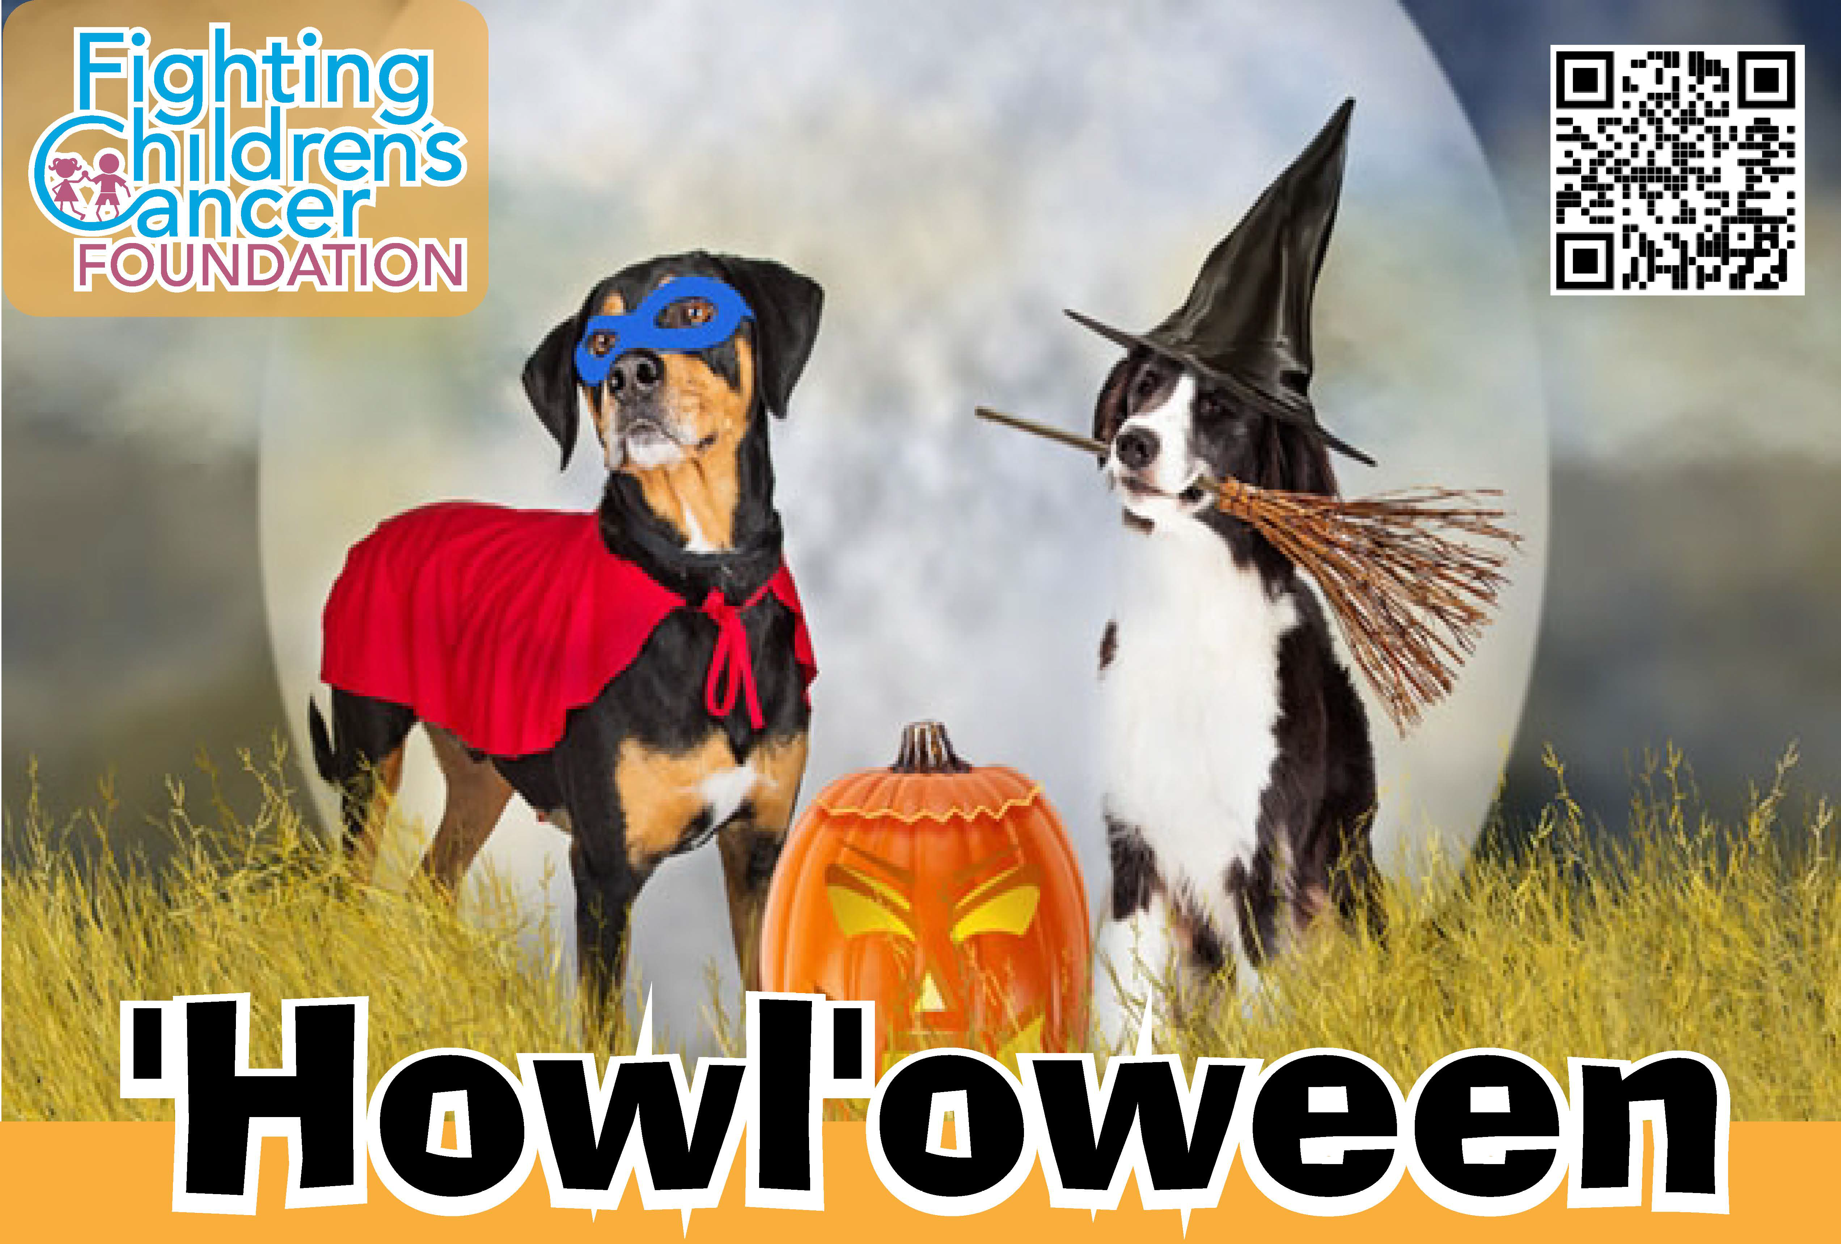
Saturday, Oct. 19, 2024
Central Park of Morris County, Parsippany.
Place an ad in our program !
Full page (8 1/2 x 5 1/2) : $125.00
Half page (3 ¾ x 4 ½) : $75.00
Business card : $50.00
Acceptable File Types: .png, .jpg.
Deadline : October 9th. 2024
Please send copy to : chelsea.hinkle@gmail.com
Make payment at: https://www.fccf.info/events/howl-2/

THANK YOU FOR YOUR SUPPORT


For more information:
Christian Van Pelt: 973.525.2347, cvanp31@gmail.com
Chelsea Hinkle: 856.906.6052, chelsea.hinkle@gmail.com

